## horizontal line

Backpropagation in RNN

21.05.2025

# Backpropagation in RNN

| Text | o/p |
| --- | --- |
| Cat mat rat | 1 |
| Rat rat mat | 1 |
| Mat mat cat | 0 |

|  | X | Y |
| --- | --- | --- |
| X1 | [1 0 0] [0 1 0] [0 0 1] | 1 |
| X2 | [0 0 1] [0 0 1] [0 1 0] | 1 |
| X3 | [0 1 0] [0 1 0] [1 0 0] | 0 |



O1 = f(x11wi + OoWh)

O2 = f(x12wi + O1Wh)

O3 = f(x13wi + O2Wh)

Y_hat =



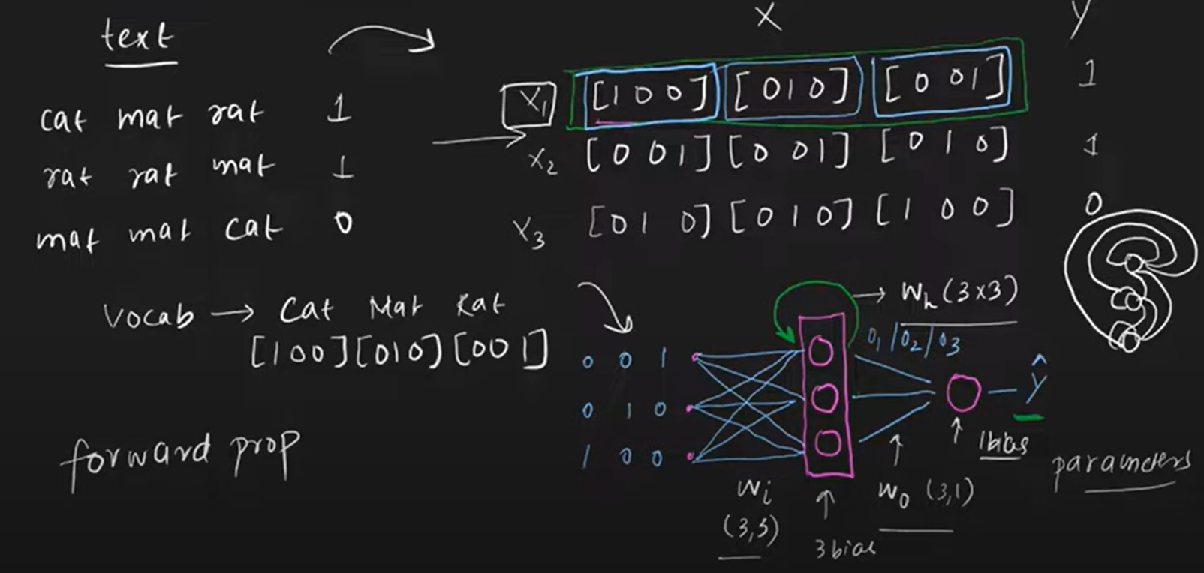

We need to update the gradients of the different weights Wi, Wh , Wo.

Wi = Wi -

Wh = Wh -

Wo = Wo -

## We need to find out the 3 gradients :

## 



 

